**SEARCH RESULTS FOR MAIZE (CORN) FOR Texas, USA; OMNI-AI**

**1) Average weather pattern for Texas, USA**

Climate Texas

Jan Feb Mar Apr May Jun

Average high in °F: 62 65 72 80 87 92

Average low in °F: 42 45 51 59 67 72

Av. precipitation in inch: 2.2 2.01 2.76 2.09 4.37 4.33

Jul Aug Sep Oct Nov Dec

Average high in °F: 96 97 91 82 71 63

Average low in °F: 74 75 69 61 51 42

Av. precipitation in inch: 1.89 2.36 2.99 3.9 2.95 2.4

**2) Rainfall pattern for Texas, USA**

* In western areas April and May are the months with the highest rainfall.
* But approaching the Gulf Coast, **September** becomes the year's wettest month on average.

**3) Average amount of rainfall in mm for Texas, USA**

* The average annual precipitation values for Texas ranges from **32 to 36 inches per year**.

**4) Average regional climate for Texas, USA**

* The eastern third of **Texas** has a Subtropical Humid **climate** that is most noted for warm summers.
* The central third of **Texas** has a Subtropical Sub-humid **climate** characterized by hot summers and dry winters.

**5) Specific natural disasters that affect Texas, USA**

* Flooding
* Wildfires
* Tornados
* Hurricanes
* Hail storms
* Sinkholes
* Drought

**6) Natural disasters with highest occurring frequency in Texas, USA**

* Flooding
* Wildfires
* Tornados

**7) General soil type in Texas, USA**

* Upland soils commonly have a thin, light-colored, acid **sandy** loam surface layer over dense, mottled red, yellow, and gray claypan subsoils.
* Bottomlands are deep, highly fertile, reddish-brown to dark-gray **loamy** to clayey soils. Land use is mainly rangeland

**8) Propagation or farming methods for maize in Texas, USA**

* Mostly large scale mechanized farming.
* Hand planting is common amongst small-scale farmers.

**9) Historical planting time for maize in Texas, USA**

* April

**10) Best planting time for maize in Texas, USA**

* March

**11) Historical Harvesting time for maize in Texas, USA**

* August

**12) Best Harvesting time for maize in Texas, USA**

* June-July

**13) Natural fertilizer options for maize per area per country.**

* Composted dairy manure

**14) Chemical fertilizer options for maize in Texas, USA**

* **Soils** already contain enough **potassium**, magnesium and other **nutrients** for corn to grow healthily.
* An all-purpose fertilizer containing more **nitrogen** and **phosphorus** than **potassium** -- such as a 16-16-8 ratio fertilizer -- helps ensure healthy growth when applied to the soil before planting.

**15) Common Maize crop disease to expect during the farming season in Texas, USA**

* Common Smut
* Maize Dwarf Mosiac Virus
* Northern Corn Leaf Blight
* Stalk Rots

**16) Top three Maize crop diseases to expect during the farming season in Texas, USA**

* Maize Dwarf Mosiac Virus
* Northern Corn Leaf Blight
* Stalk Rots

**17) Common Maize crop pests to expect during the farming season in Texas, USA**

* Cutworms
* Corn earworm
* Fall Armyworm
* Mexican Rootworm
* Aphids

**18) Top three** **Maize crop pests to expect during the farming season in Texas, USA**

* Corn earworm
* Fall Armyworm
* Mexican Rootworm

**19)** **Best soil type for maize in Texas, USA**

Light sandy loam soil

**20) Agric policy in direct relation to Maize farming in Texas, USA**

* No direct agirc policy benefiting maize farmers

**21) Type of government subsidy for maize in Texas, USA**

* No known Government subsidy geared directly towards maize

**22) Lowest Market price over the past three years for Maize in Texas, USA**

* $3 per bushel

**23) Highest Market price over the past three years for Maize in Texas, USA**

* $4.5 per bushel

**24) Best Market price over the past two years for Maize in Texas, USA**

* $4.5 per bushel

**25) Historically best month to sell harvested maize in the year in Texas, USA**

* Best months to sell corn for the highest prices: June and July

**26) Top three areas of demand of Maize in Texas, USA**

* Production of industrial ethanol.
* The major domestic use of corn is as feed grain for livestock.

**27) Top countries of demand for** **maize from Texas, USA**

* Japan
* Mexico
* Colombia

**28) Best storage option for harvested Maize grains in Texas, USA.**

* Store in mechanized silos with moisture control and grain drying features.

This is done either on-site at the farm or commercial co-operative or a maize storage companies.

**29) General life cycle of Maize in Texas, USA**

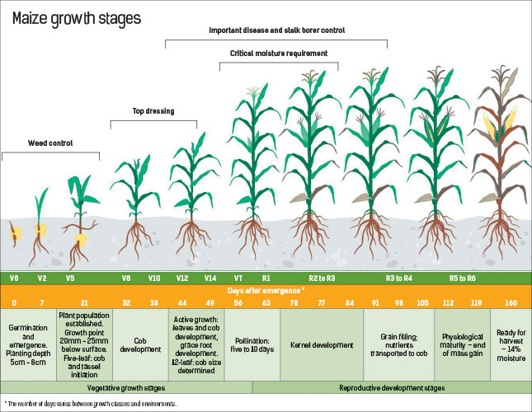

**30) Top three varieties of Maize in Texas, USA**

* Pioneer 31B13
* DeKalb 687
* Texas Seed TS 8811
* Triumph 1866Bt.